1. Where do text models currently have a major deficiency?

* Generating correct response

* sometimes not context appropriate

2. What are possible negative societal implications of text generation models?

Spread wrong nformation  
3. In situations where a model might make mistakes, and those mistakes could be  
harmful, what is a good alternative to automating a process?

Treat it as a way to help human identify thing, not the entire automatic process. For example, in hospital, help doctor if he forget or not realizing certain things, but not replacing doctor.

Involve the human process inside.

Three layer process

Layer 1: strictly with human

Layer 2 : Computer do but stricly supervised with human

Layter 3: gradually expand but still have human inside  
4. What kind of tabular data is deep learning particularly good at?

* It is good at increas variety of column such as
  + Natural Language
  + High cardinality categorcal column
    - ZIP CODE
    - ID

*High cardinality means a lot of unique values*

5. What’s a key downside of directly using a deep learning model for recommenda‐  
tion systems?

The model might not recommend something new but the old thing that the other user like, which could be something that you already like. Amazon example in the book.  
6. What are the steps of the Drivetrain Approach?

* Define the objective
* What is the lever, the input that you can do to do the objective
* What is the input that you can collect to make that happen
* How is your approach gonna affect the origin objective

7. How do the steps of the Drivetrain Approach map to a recommendation system?

* what is the goal of the recommendation system: Delighting customer with the item that they WOULD NOT HAVE PURCHASE WITHOUT RECOMMENDATION

* What is the input require for that: The lever is ranking of the recommendation

* What data you need to collect from the customer for the recommendation system to happen

* How would the recommendation system affect the user in the end?

8. Create an image recognition model using data you curate, and deploy it on the  
web.

DO THIS LATER WITH NEW INSPIRING PROJECT

9. What is DataLoaders?

Dataloaders is just a class that help you with training and testing, it provde data for your model

The general data type of the data that you are going to load?  
10. What four things do we need to tell fastai to create DataLoaders?

* The type of the independent and dependent variable ( block )
* Any twist, cropping and augmentation?
* Name of the dependent variable
* How much data are you going to split? 80 20? (splitter)

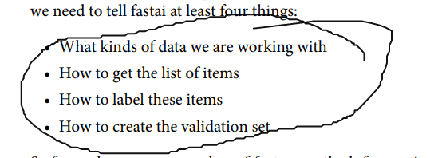

11. What does the splitter parameter to DataBlock do?

It splits the data into training set and validation set

12. How do we ensure a random split always gives the same validation set?

We use the seeds, the seeds determine how we cut it.

13. What letters are often used to signify the independent and dependent variables?

X for independent  
y for dependent

14. What’s the difference between the crop, pad, and squish resize approaches? When  
might you choose one over the others?

Crop: cut a part of the picture, but keep the same

Pad: if the image is not fit, fill the empty space with dark segments

Squish: expand to fit the image to fit the size desired, will alternate the picture

All of these approaches seem somewhat wasteful or problematic. If we squish or  
stretch the images, they end up as unrealistic shapes, leading to a model that learns  
that things look different from how they actually are, which we would expect to result  
in lower accuracy. If we crop the images, we remove some of the features that allow us  
to perform recognition.

15. What is data augmentation? Why is it needed?

Data augmentation is to slightly change the orientaton and representation of the image, it is needed because a slightly change of angle can confuse the computer already, so you need to augment the picture in order to train the model better.

*Data augmentation* refers to creating random variations of our input data, such that  
they appear different **but do not change the meaning of the data.**

16. Provide an example of where the bear classification model might work poorly in  
production, due to structural or style differences in the training data.

* Video is hard to detect than image
* Maybe you can only picture the back of the bear, which fuck up because the computer have never been trained with this type of image before
* Image in real life is not perfect  
  17. What is the difference between item_tfms and batch_tfms?
* Item-tfms transform the item
* Batch transform transform multiple item altogether, utlize the GPU better  
  18. What is a confusion matrix?
* The matrix that show the results with the errors you made. How much is correct identfed, and how much is wrong and how many it predicts wrong for specific category  
  19. What does export save?  
  export save the architecture and trained parameters of your model  
  20. What is it called when we use a model for making predictions, instead of  
  training?
* When we use a model for getting predictions, instead of training, we call it *inference*

21. What are IPython widgets?

* Python library for GUI, button , label …  
  22. When would you use a CPU for deployment? When might a GPU be better?
* When the computation or processing only require one image or small amount of data
* The GPU is better if you have to handle a lot of pictures/data  
  23. What are the downsides of deploying your app to a server, instead of to a client  
  (or edge) device such as a phone or PC?
* Internet independent
* Processing speed might not good

24. What are three examples of problems that could occur when rolling out a bear  
warning system in practice?

* Video processing will be different from Image processing. Might need a different architecture
* Require real bear picture with different angle( back ), which is limited. Also bear can have noise object around. Need a way to filter it.

25. What is out-of-domain data?

Unexpected image types arise in the data when the model is being used in production (this is  
known as checking for *out-of-domain* data).  
26. What is domain shift?

whereby the type of data that our model sees changes over time. For  
instance, an insurance company may use a deep learning model as part of its pricing  
and risk algorithm

27. What are the three steps in the deployment process?

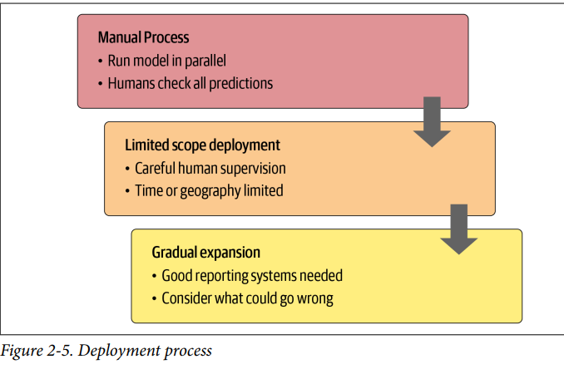  
Further Research

1. Consider how the Drivetrain Approach maps to a project or problem you’re  
interested in.

2. When might it be best to avoid certain types of data augmentation?

3. For a project you’re interested in applying deep learning to, consider the thought  
experiment, “What would happen if it went really, really well?”

4. Start a blog and write your first blog post. For instance, write about what you  
think deep learning might be useful for in a domain you’re interested in.